|  |  |
| --- | --- |
| Program No | 1 |
| Roll No | 1333 |
| Unit | Unit 1 |
| Program | Bubble sort |

**Source Code:**

#include<iostream> using namespace std; int main()

{

int a[20], n; int i, j, tmp;

cout << "*** Bubble Sort ***" << endl << endl;

//get the size of the array

cout << "enter the size of the array: "; cin >> n;

cout << "Enter the values in the array: " << endl; for(i=0; i<n; i++)

{

cin >> a[i];

} //end of for

//Bubble sort for(i=0; i<n-1; i++)

{

for(j=i+1; j<n; j++)

{

if(a[i] > a[j])

{

tmp = a[i]; a[i] = a[j]; a[j] = tmp;

}//end of if

}// end of j

} //end of for i

cout << endl;

cout << "sorted array: "<<endl; for(i=0; i<n; i++)

{

cout << a[i] << endl;

}

}//end of main

**Output:**

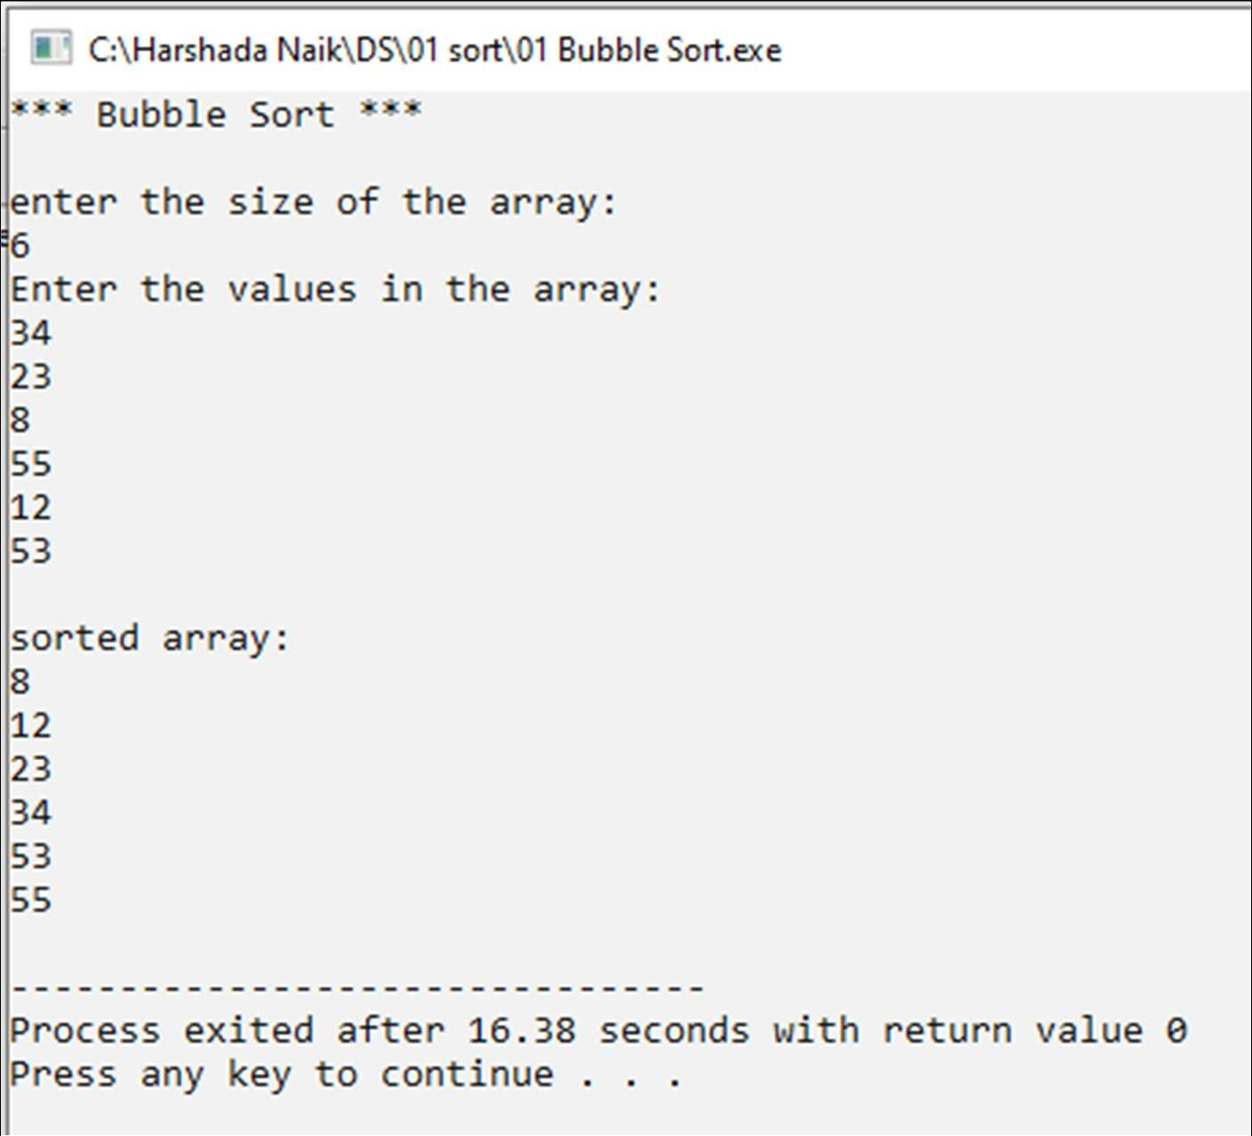

|  |  |
| --- | --- |
| Program No | 2 |
| Roll No | 1333 |
| Unit | Unit 1 |
| Program | Selection sort |

**Source Code:**

#include<iostream> using namespace std; int main()

{

int arr[20], n;

int i, j, tmp, min, loc;

cout << "***SELECTION SORT***" << endl << endl;

//get the size of array

cout << "Enter the size of the array:" << endl; cin >> n;

//get the values in array

cout << "Enter the values in array:" << endl; for(i=0; i<n; i++)

{

cin >> arr[i];

} //end of for

//Selection sort for(i=0; i<n; i++)

{

min = arr[i]; loc = i;

for(j=i+1; j<n; j++)

{

if(arr[j] < min)

{

min = arr[j]; loc =j;

} // end of if

} // end of j

//fount the smallest value and its loc at min and loc

//swap

tmp = arr[i]; arr[i] = arr[loc]; arr[loc] = tmp;

} //end of i

//Dispay cout << endl;

cout << "Sorted array:" << endl; for(i=0; i<n; i++)

{

cout << arr[i] << endl;

}

} //end of main

**Output:**

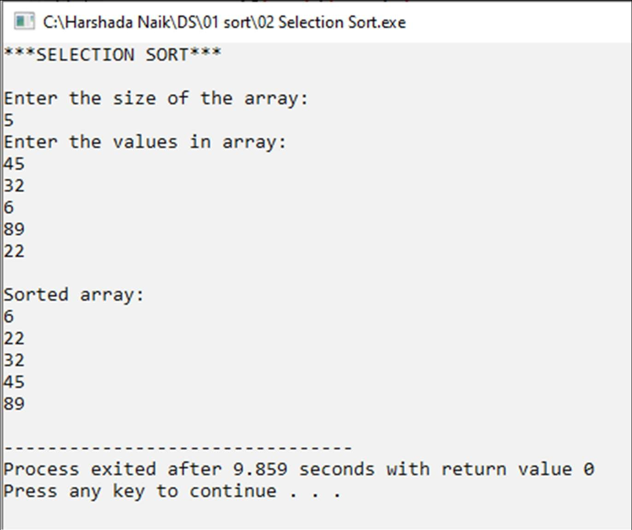

|  |  |
| --- | --- |
| Program No | 3 |
| Roll No | 1333 |
| Unit | Unit 1 |
| Program | Insertion sort |

**Source Code:**

#include<iostream> using namespace std; int main()

{

int n, arr[20]; int i,j,tmp,loc;

cout << "*** Insertion Sort ***" << endl << endl; cout << "Enter the size of the array:" << endl;

cin >> n;

cout << "Enter the elements of the array: " << endl; for(i=0;i<n;i++)

{

cin >> arr[i];

}//end of for

//Insertion Sort for(i=1 ; i<n ; i++)

{

tmp = arr[i]; loc = i - 1;

while(tmp < arr[loc] && loc >= 0)

{

arr[loc+1] = arr[loc]; loc--;

}//end of while arr[loc+1] = tmp;

}//end of for i

cout << endl << "Sorted Array:" << endl; for(i=0; i<n; i++)

{

cout << arr[i] << endl;

}

}//end of main

**Output:**

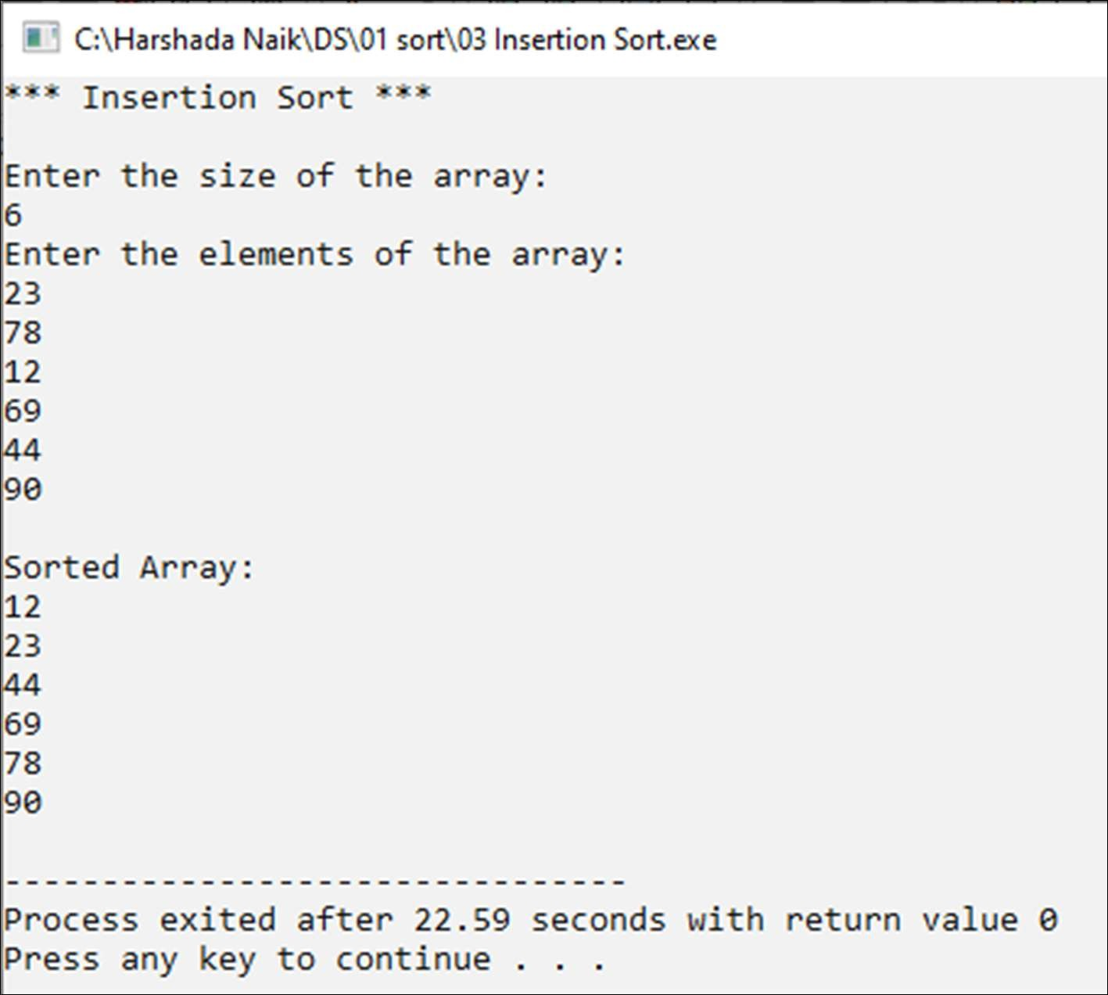

|  |  |
| --- | --- |
| Program No | 4 |
| Roll No | 1333 |
| Unit | Unit 1 |
| Program | Shell sort |

**Source Code:**

#include<iostream> #include<math.h>

using namespace std; int main()

{

int n, arr[20] , i, gap,loc,extractData;

cout << "*** Shell Sort ***\n" << endl; cout << " Enter the size of the Array:"; cin >> n;

cout << endl << "Enter the elements of Array:" << endl; for(i=0;i<n;i++)

{

cin >> arr[i];

}// end of for

gap = floor(n/2); while(gap > 0)

{

for(i=0; i<n-gap;i++)

{

extractData = arr[i+gap]; loc = i + gap;

while((loc - gap) >= 0 && extractData < arr[loc - gap])

{

arr[loc] = arr[loc - gap]; loc = loc - gap;

}

arr[loc] = extractData;

}//end of for i

gap = floor(gap/2);

}//end of while

cout << endl << "Sorted Array:"<< endl;

for(i = 0; i < n; i++)

{

cout << arr[i] << endl;

}

}// end of main

**Output:**

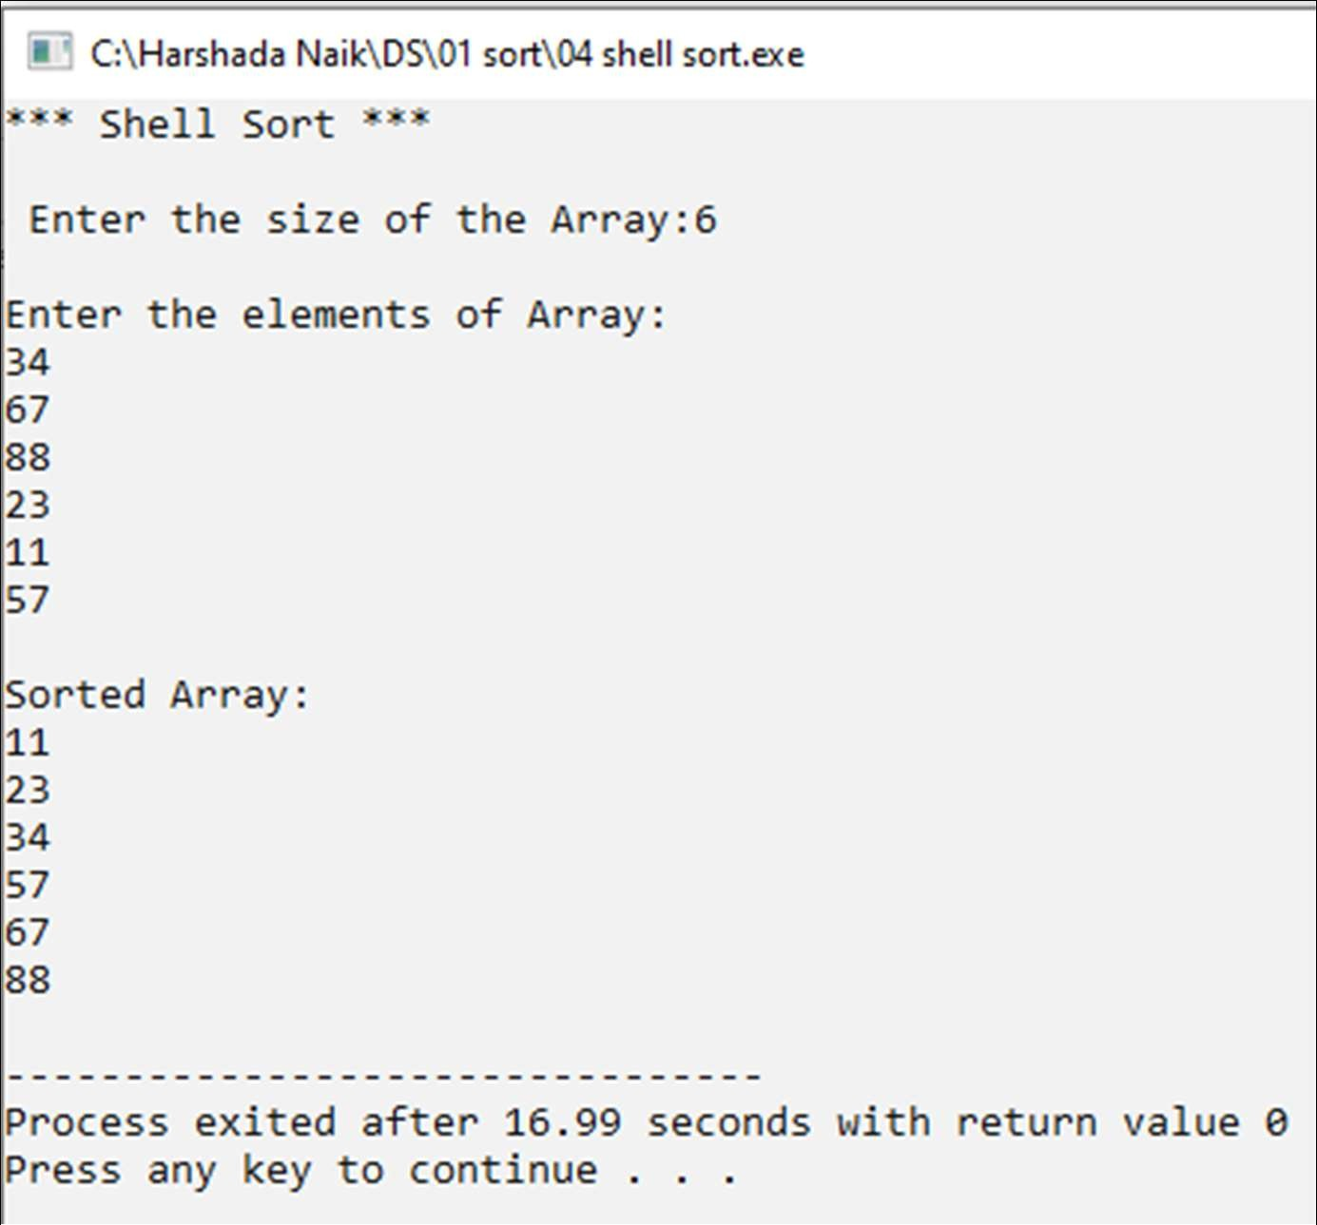

|  |  |
| --- | --- |
| Program No | 5 |
| Roll No | 1333 |
| Unit | Unit 1 |
| Program | Radix sort |

**Source Code:**

#include <iostream> using namespace std;

int main()

{

int n, i, arr[20], passes = 0, max; int bucket[10][20],b_count[10];

int j,k,r,x;

cout << "***Radix Sort***" << endl;

cout << "Enter the size of the array:" << endl; cin >> n;

cout << "Enter elements of the array:" << endl; for(i = 0; i<n; i++)

{

cin >> arr[i];

}

//find the Largest Number in the array

max = arr[0];

for(int i = 1; i < n; i++)

{

if(max < arr[i])

{

max = arr[i];

}

}

//count the number of digits in max - define the # of passes while(max > 0)

{

passes++; max /= 10;

}

//radix sort int divisor=1;

for(x=1; x<=passes; x++)

{

//initialize the b_count for(k=0; k<10; k++)

{

b_count[k] = 0;

}

//2. chek digit and place in bin, update b_count for(i=0; i<n; i++)

{

r = (arr[i]/divisor) % 10; bucket[r][b_count[r]]= arr[i]; b_count[r]++;

}

//3. collect the bins i=0;

for(k=0; k<10; k++)

{

for(j=0; j<b_count[k]; j++)

{

arr[i] = bucket[k][j]; i++;

}//end for j

}// end for k

divisor = divisor * 10;

}//end for x

cout << endl << endl;

cout << "sorted array" << endl; for(i=0; i<n; i++)

{

cout << arr[i] << " ";

}

}

**Output:**

# MUMBAI EDUCATIONAL TRUST

## MET Institute of Computer Science

